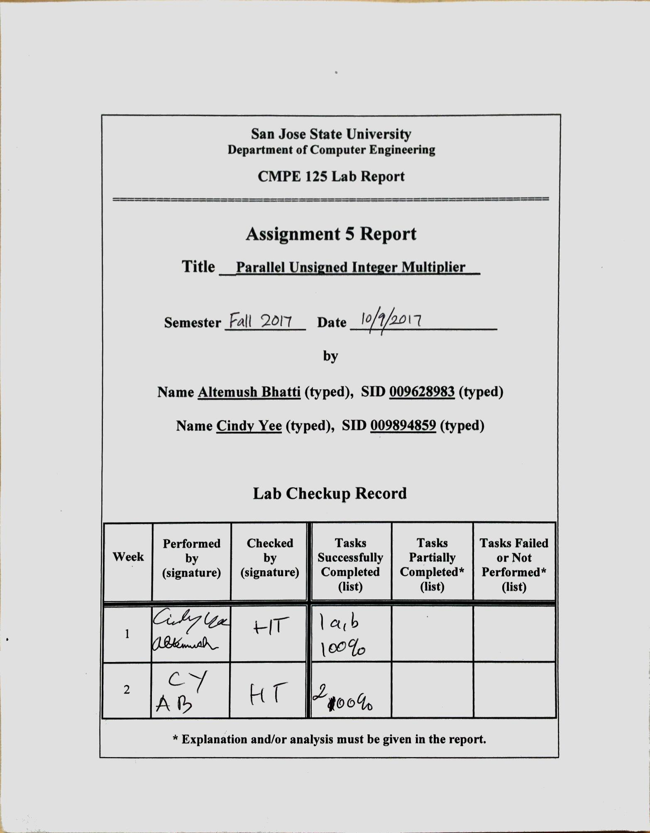

**Introduction**

The purpose of this lab was to be familiar with both combinational and sequential building blocks and the design/verification/validation flow and Engineering Design Automation tools used in the lab. We also familiarized ourselves with the concept and technique of pipelining. In this lab we designed a 4-bit parallel combinational unsigned integer multiplier using AND gates, shift and zero padding, and carry-look-ahead adders. We also designed the same multiplier using registers. Two registers were used for each input, two were used as state registers, and one was used to hold the product of the multiplier. For both multipliers, self-checking testbenches were written for simulation. The pipelined multiplier was implemented on the Nexys4 DDR FPGA board.

**Design Methodology**

The 4-bit parallel unsigned integer multiplier is made up of four AND gates, four zero and shift paddings, and three carry-look-ahead adders. Each input of the multiplier is four bits, and there are four 2-input AND gates.

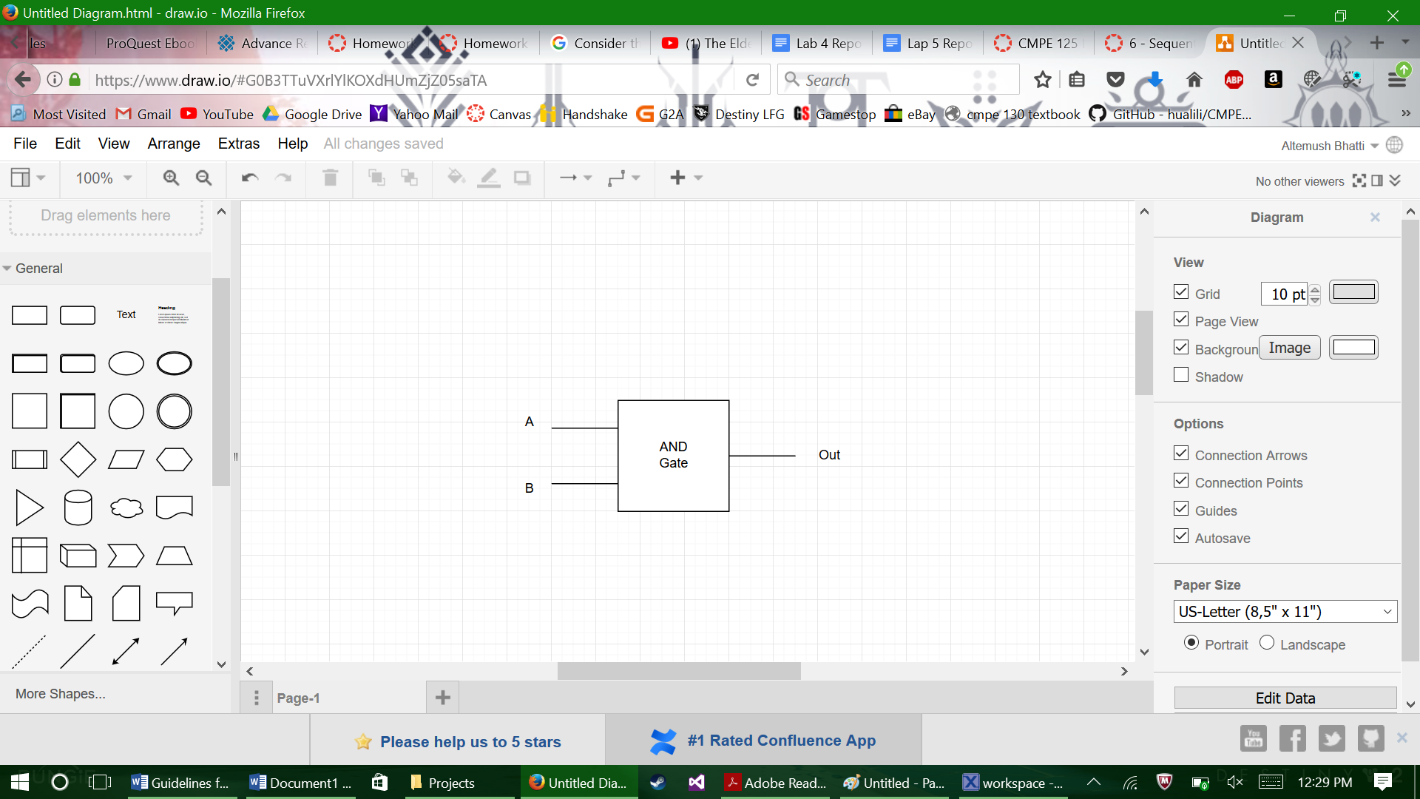

*Figure 1*: 2-input AND gate

*Table 1*: AND gate truth table

|  |  |  |
| --- | --- | --- |
| Input A | Input B | Out |
| 0 | 0 | 0 |
| 0 | 1 | 0 |
| 1 | 0 | 0 |
| 1 | 1 | 1 |

The outputs of each AND gate are the inputs of the zero and shift padding, in which zeros were concatenated with these inputs so that the four-bit outputs of the AND gates can be turned into eight-bit values. Two sets of these values were used as the inputs of two CLA adders, and the outputs of these adders were used as the inputs of one final CLA adder, whose output is the product of the multiplier.

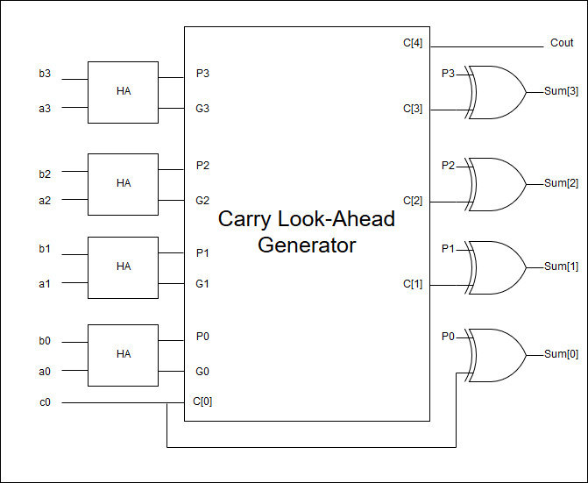

*Figure 2*: Carry look-ahead adder with half adders, carry look-ahead generator, and XOR gates.

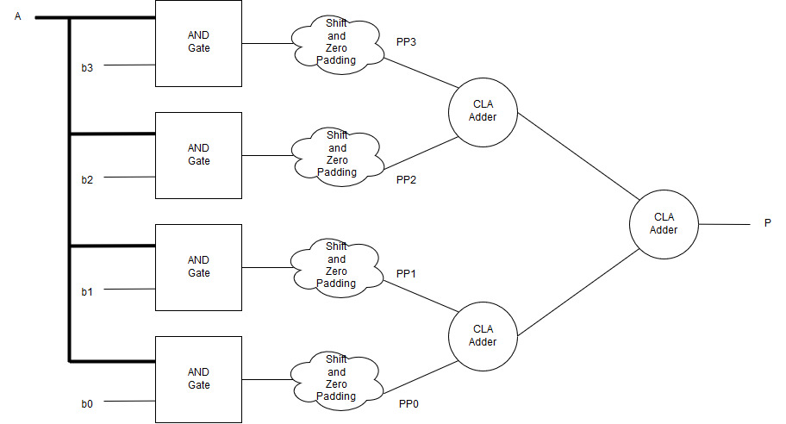

*Figure 3*: Parallel unsigned integer multiplier with four AND gates, shift and zero padding, and three CLA adders.

The pipelined multiplier is similar to the multiplier described above. However, the inputs are stored in registers; each input has its own register. The outputs of the first two CLA adders are stored in registers known as state registers. The product of the multiplier is also stored in a register.

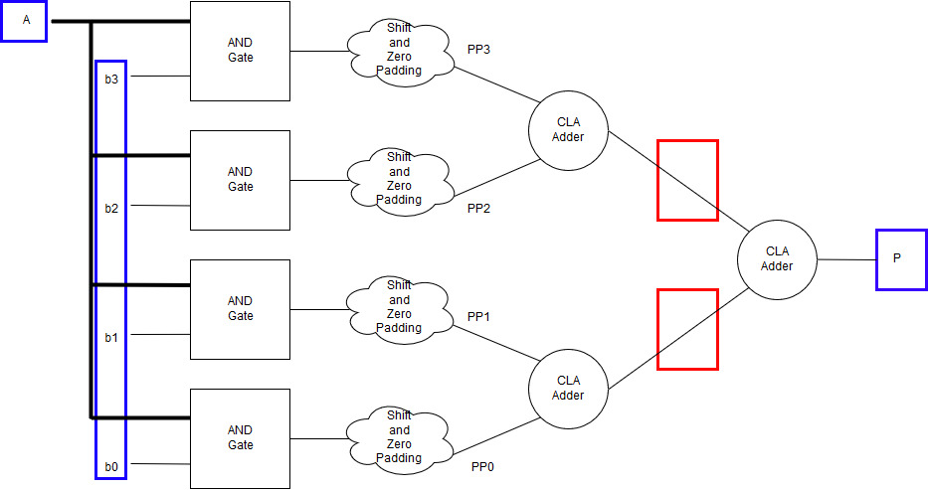

*Figure 4*: Pipelined multiplier with registers. Input/output register are in blue, and state registers are in red.

Table 2: List of modules used in the lab

|  |  |
| --- | --- |
| Module name | Description |
| ***multiplier.v*** | **design source for the combinational multiplier** |
| ***multiplier_tb.v*** | **self-checking testbench for combinational multiplier** |
| ***PL_multiplier_main.v*** | **design source for the pipelined multiplier** |
| ***PL_multiplier_tb.v*** | **self-checking testbench for the pipelined multiplier** |
| ***D_Reg.v*** | **design source for parameterized D-register** |
| ***PL_multiplier_sub1.v*** | **submodule to AND A and B, zero pad, and sum PP0 with PP1 and PP2 with PP3** |
| ***and_AB.v*** | **helper module to AND all A bits to one B bit ---A[3:0]*B[i]** |
| ***CLA_adder.v*** | **design code for a four bit Carry Look-Ahead adder** |
| ***half_adder.v*** | **half adder module used in the four bit CLA adder** |
| ***PL_multiplier_sub2.v*** | **submodule to add all PP’s together** |
| ***button_debouncer.v*** | **design source for debouncer** |
| ***clk_gen.v*** | **utility module to generate the clock** |
| ***bcd_to_7seg.v*** | **utility module to display LEDs on 7-seg** |
| ***led_mux.v*** | **utility module to select what goes to which 7-seg** |
| ***PL_multiplier_fpga.v*** | **top level module for pipeline multiplier fpga verification** |
| ***PL_multiplier_fpga.xdc*** | **constraint file for the pipelined multiplier** |

**Simulation Results**

The simulation for the combinational multiplier was a success, with the self checking test-bench outputting a “Test Success” message as shown in figure 5 with the full waveform showing. The test-bench ran through all possible inputs for *A_tb* and all possible inputs of *B_tb*, so the results were condensed.

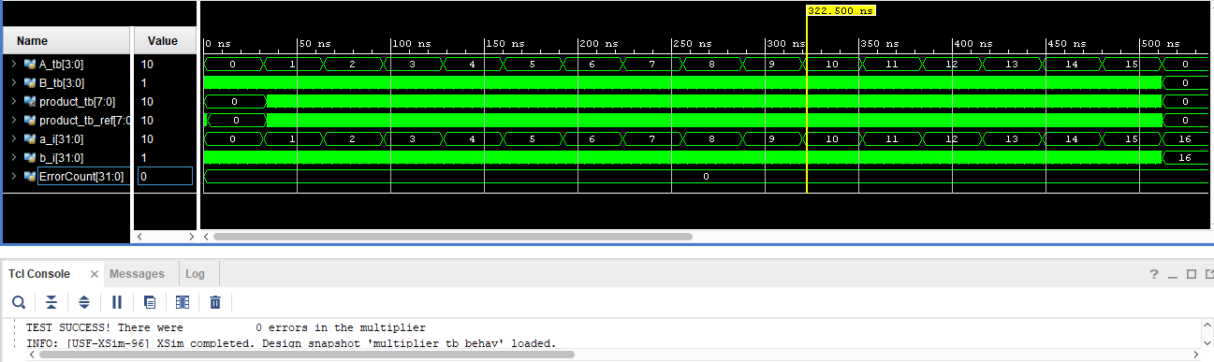

Figure 5: Combinational Multiplier simulation full waveform with success message

To get a closer look at the combinational multiplier, figure 6 was included. Since the multiplier is combinational, there is no delay shown between the inputs *A_tb* and *B_tb* and the output signal *product_tb.* From eyeball testing it can be observed that the combinational *multiplier.v* module is outputting the correct product, since the results match 9*15=135, 10*0=0, 10*1=10, and so on. From the self-checking we can also see that the combinational *multiplier.v* module output *product_tb* matches the inferred *product_tb_ref* and the success message from figure 5 implied there were no errors.

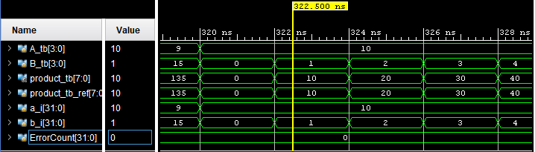

Figure 6: Combinational Multiplier simulation zoomed in waveforms

The simulation for the pipelined multiplier was also a success. Figure 7 shows the full waveform of the simulation with a self-checking testbench running through all possible inputs of *A_tb* and *B_tb.* From the success message, it was observed that there were no errors in the pipelined multiplier *PL_multiplier* module.

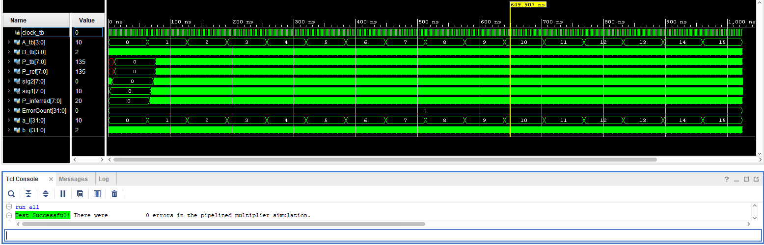

*Figure 7*: Pipelined multiplier simulation full waveform with success message

To get a closer look at the pipelined multiplier, figure 8 was included. The pipelined multiplier has total delay of three clock cycles because of the input register delay, the stage register's delay, and the output register’s delay. As the D-registers used are positive edge clock triggered and the enable is at a constant high, we can observe that at each positive edge of the clock, a new input is allowed through the registers. We can observe that 9*15, which is equal to 135 was delayed three clock cycles, as shown by the blue markers.

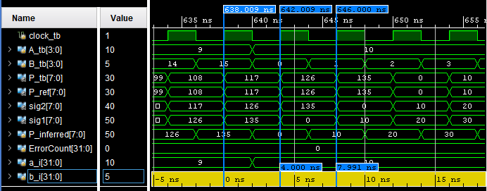

*Figure 8*: Pipelined multiplier simulation with zoomed in waveforms

**Verification**

The FPGA validation and verification was a success, with figure X showing the board set up with all the inputs and outputs labelled. The testing was completed by activating the reset to zero any previous inputs, entering three different sets of inputs, and observing the three respective outputs. 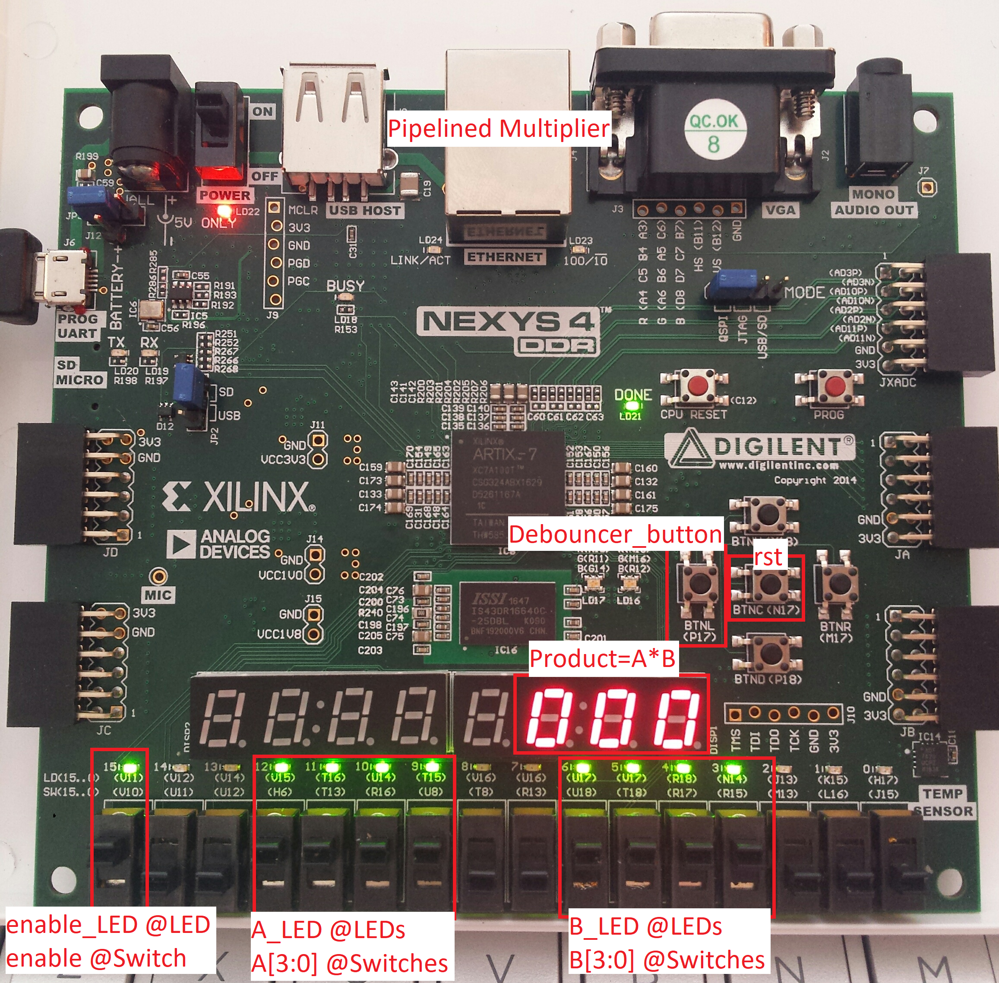Figure 9:Pipelined Multiplier FPGA setup

The first thing that should be done was to activate the reset *rst*, just in case any other inputs were entered so that the testing would be easier as shown in figure 10.

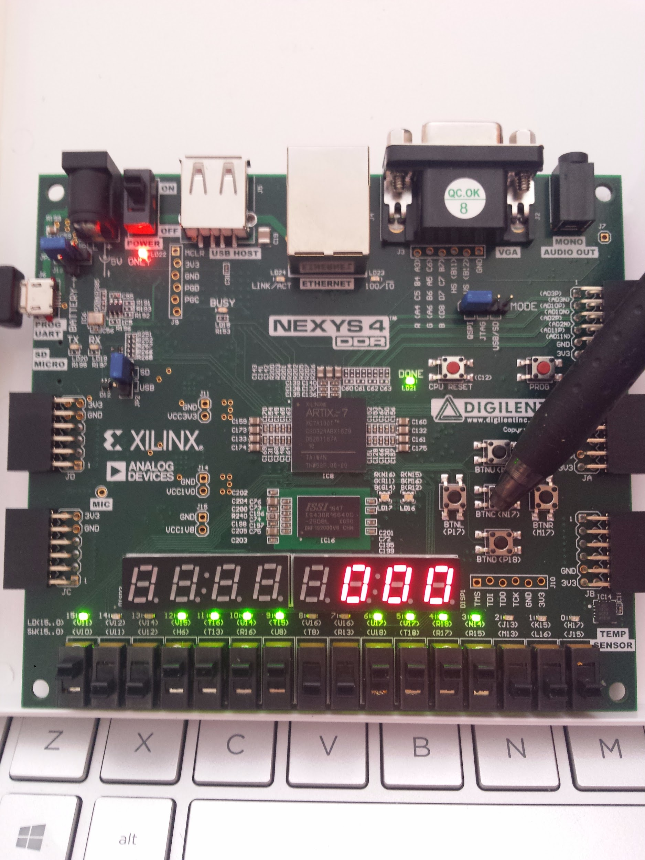

Figure 10:Reset the fpga

Figures 11 through 13 shows three different inputs being entered into the pipeline after the reset button was activated.

Figure 11 shows A=15 and B=15 being entered, which should have an expected output of 225 after three clock cycles. This counts as the first clock cycle for A=15 and B=15.

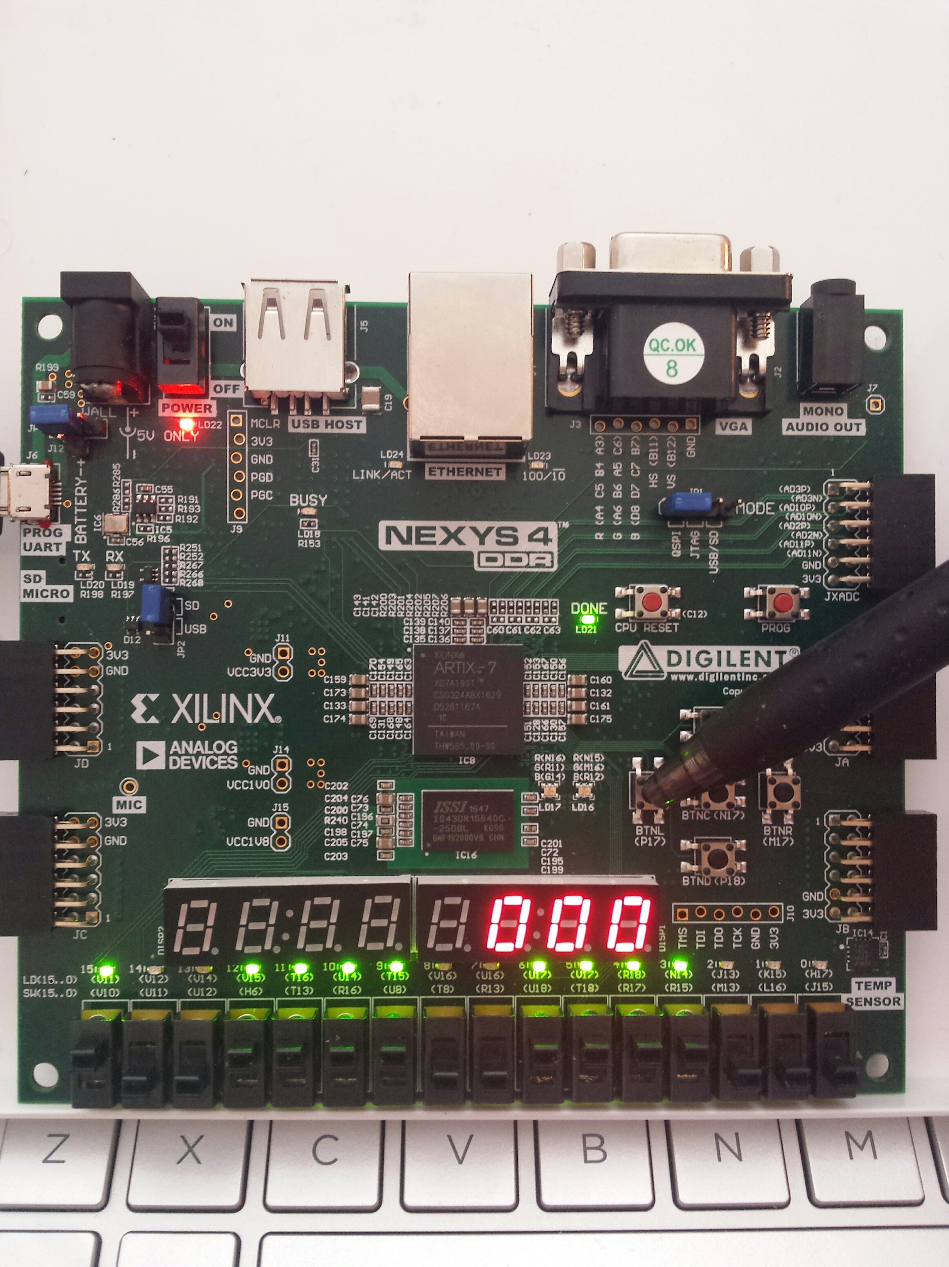

Figure 11: Inputting A=1111b=15d B=1111b=15d (1st Debouncer_button input)

Figure 12 shows A=14 and B=11 being entered, which should have an expected output of 154 after three clock cycles. This counts as the first clock cycle for A=14 and B=11 but the second for A=15 and B=15.

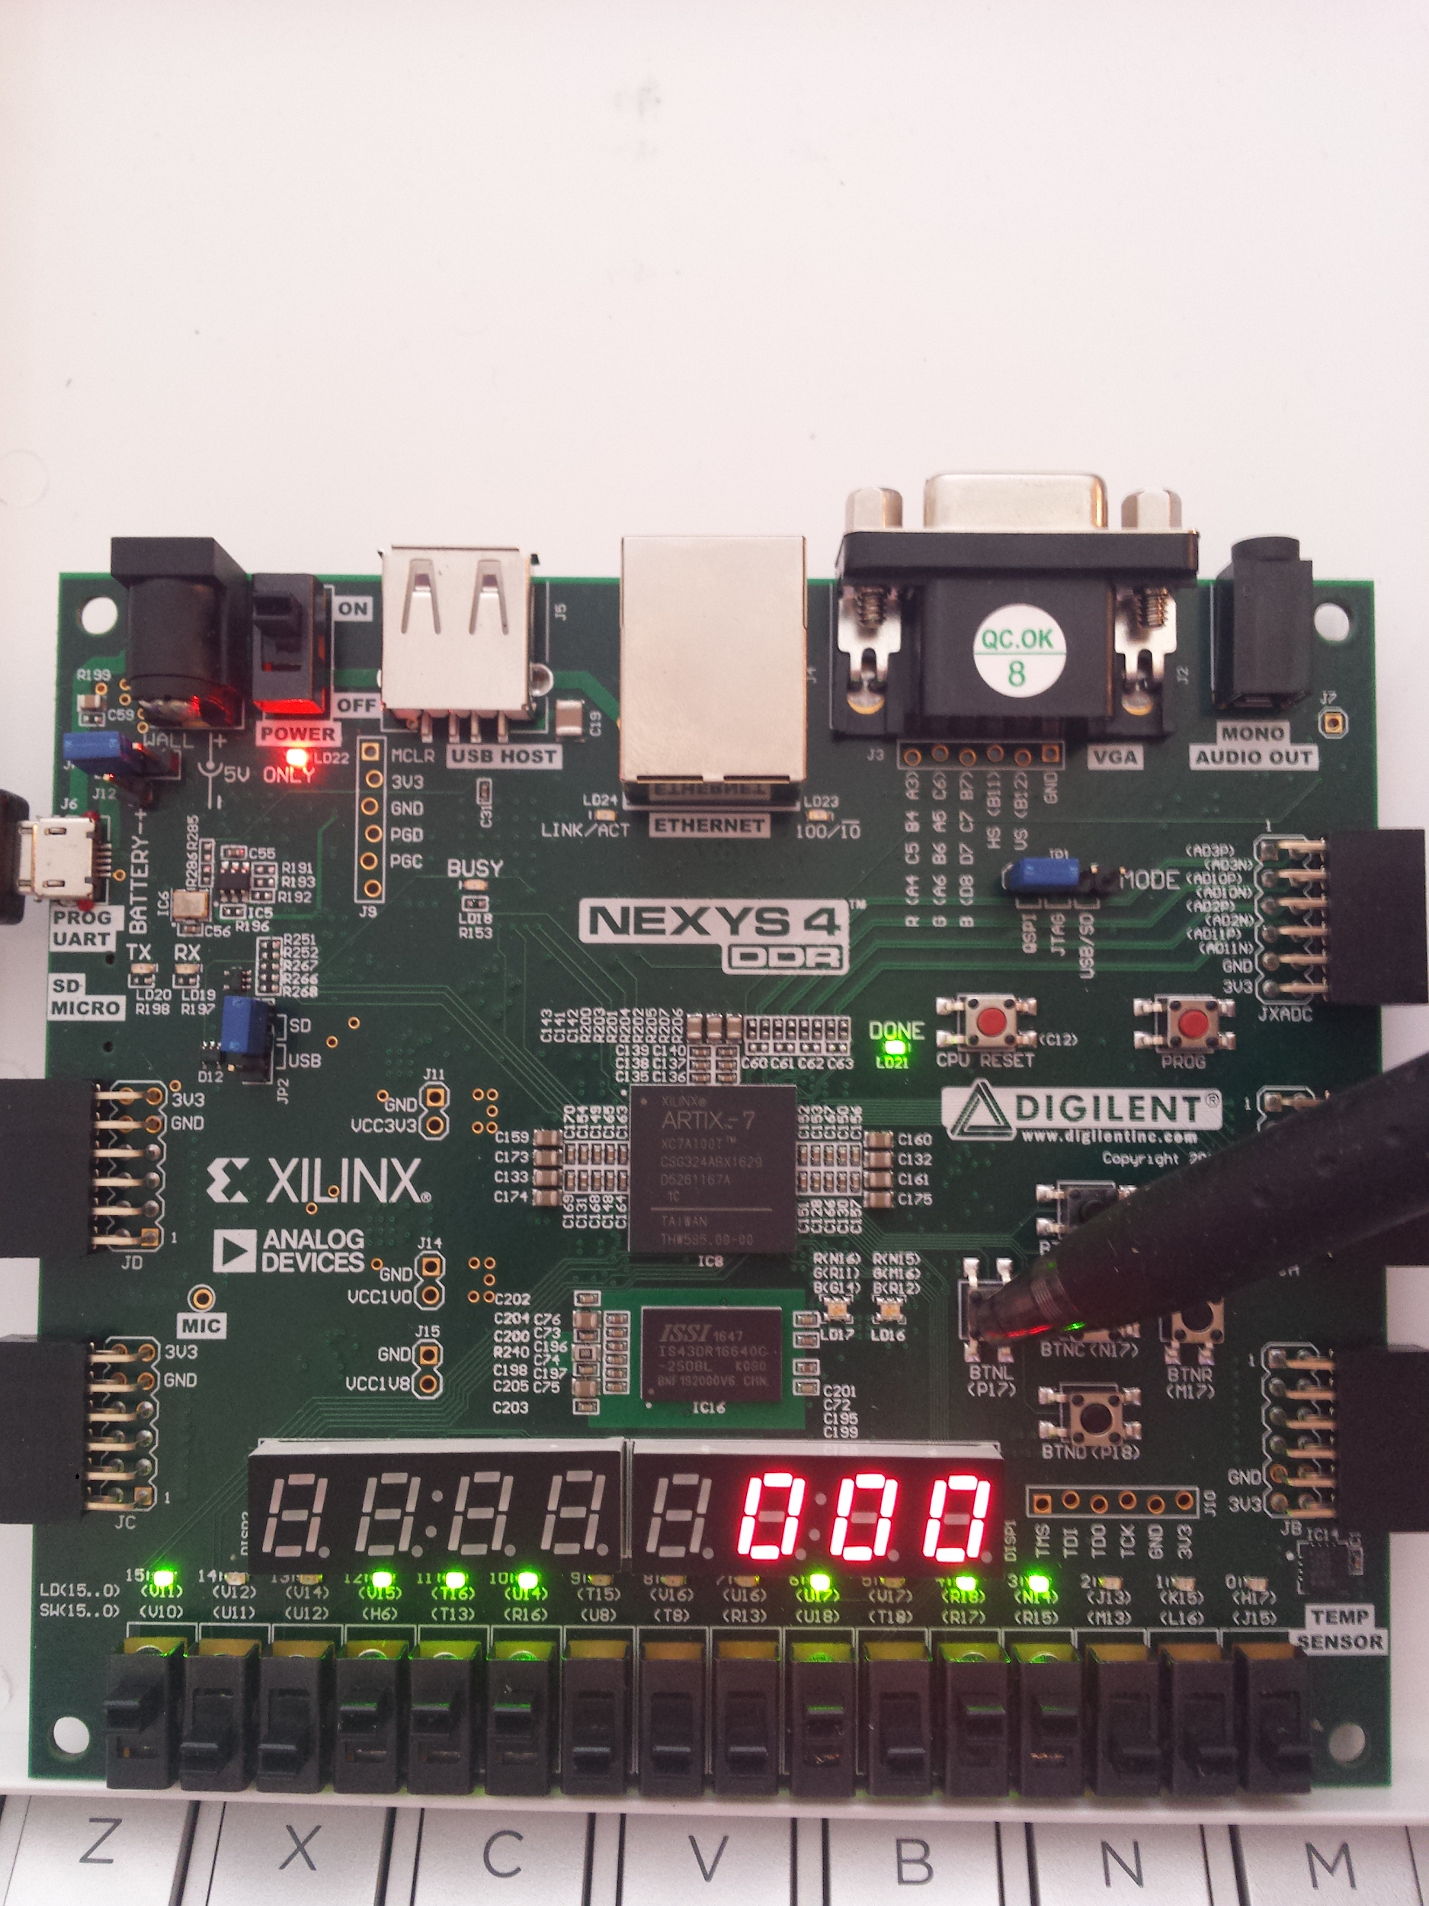

Figure 12: Inputting A=1110b=14d and B=1011b=11d (2nd Debouncer_button input)

Figure 13 shows A=9 and B=5 being entered, which should have an expected output of 45 after three clock cycles. This counts at the first clock cycle for A=9 and B=5, the second clock cycle for A=14 and B=11, and the third clock cycle for A=15 and B=15. Since this is the third clock cycle for A=15 and B=15, and the 15*15=225, 225 is displayed on the 7-segment display.

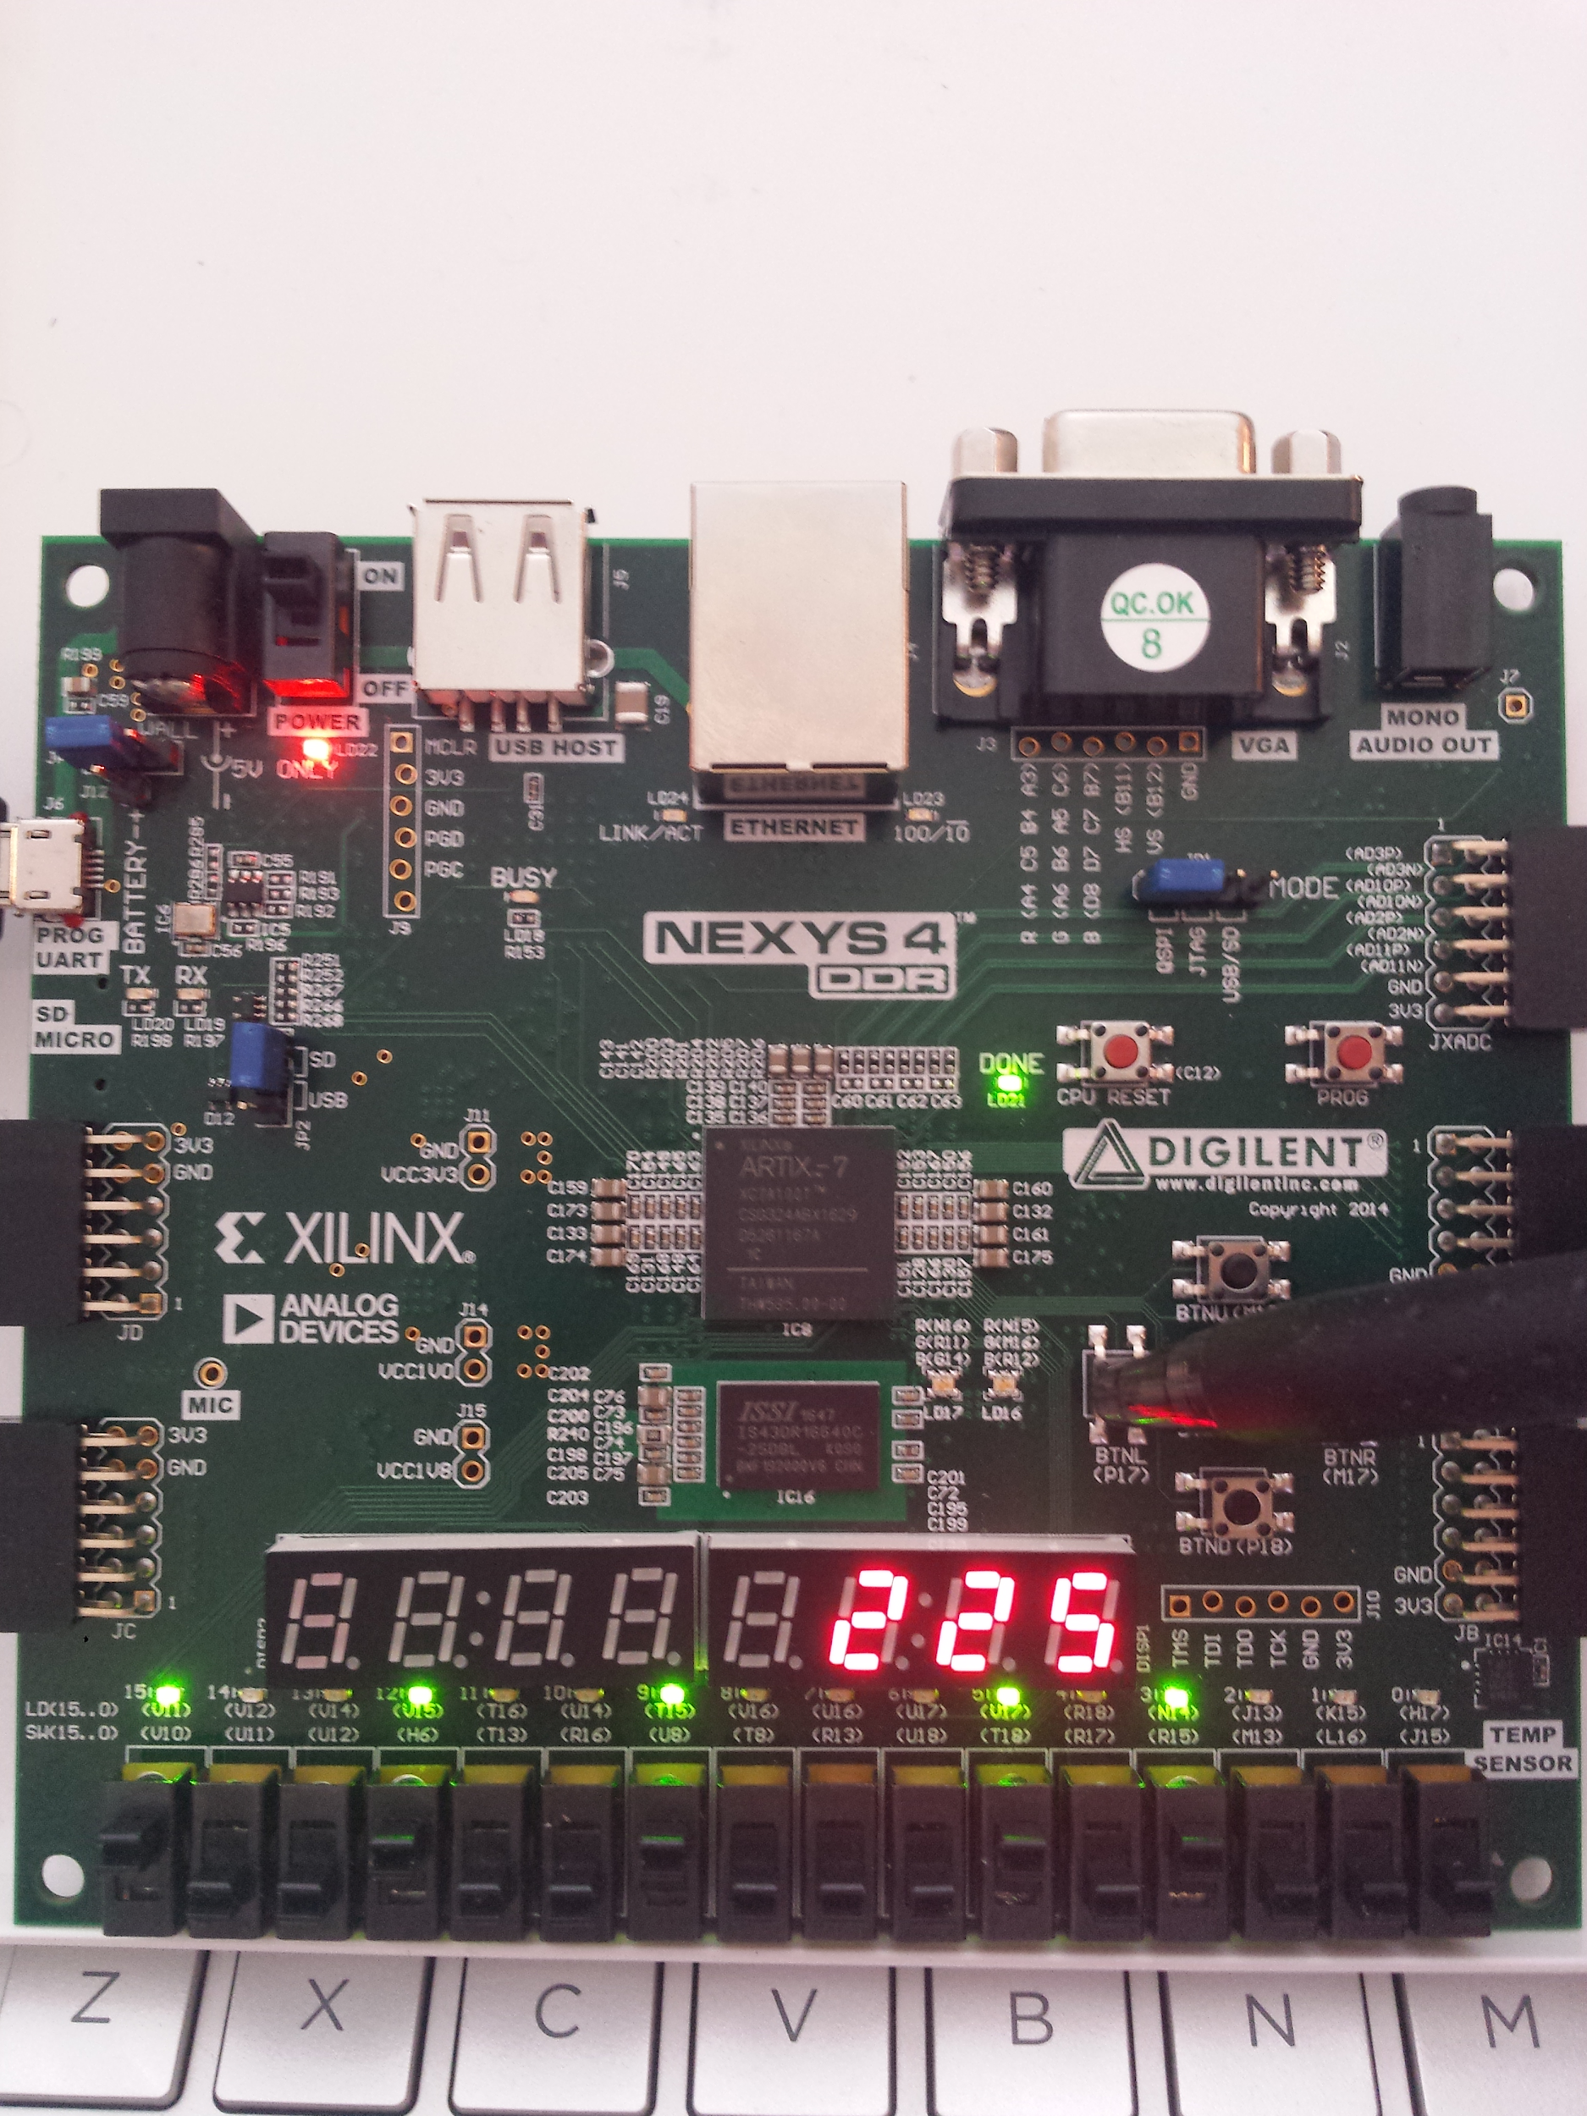

Figure 13: Input A=1001b=9d and B=0101b=5d (3rd Debouncer_button input) with Product=225

Figure 14 shows the output after activating the Debouncer_button for the 4th time. This counts at the second clock cycle for A=9 and B=5, the third clock cycle for A=14 and B=11. Since this is the third clock cycle for A=14 and B=11, and the 14*11=154, 154 is displayed on the 7-segment display.

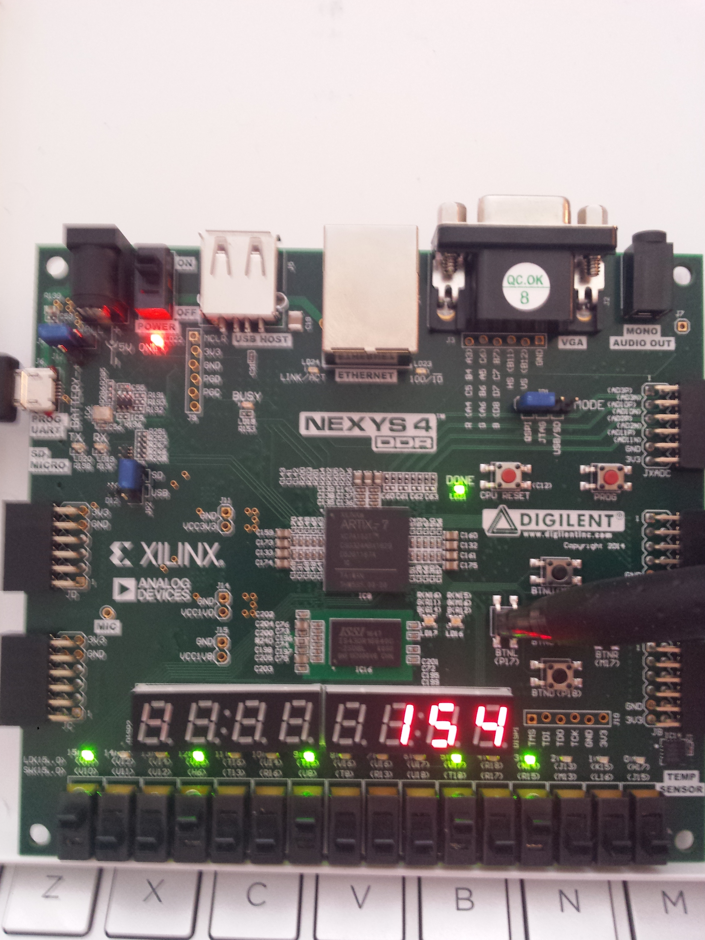

Figure 14:Output 154 after 4th Debouncer_button input from (2nd Debouncer_button input)

Figure 15 shows the output after activating the Debouncer_button for the 5th time. This counts at the third clock cycle for A=9 and B=5. Since this is the third clock cycle for A=9 and B=5, and the 9*5=45, 45 is displayed on the 7-segment display.

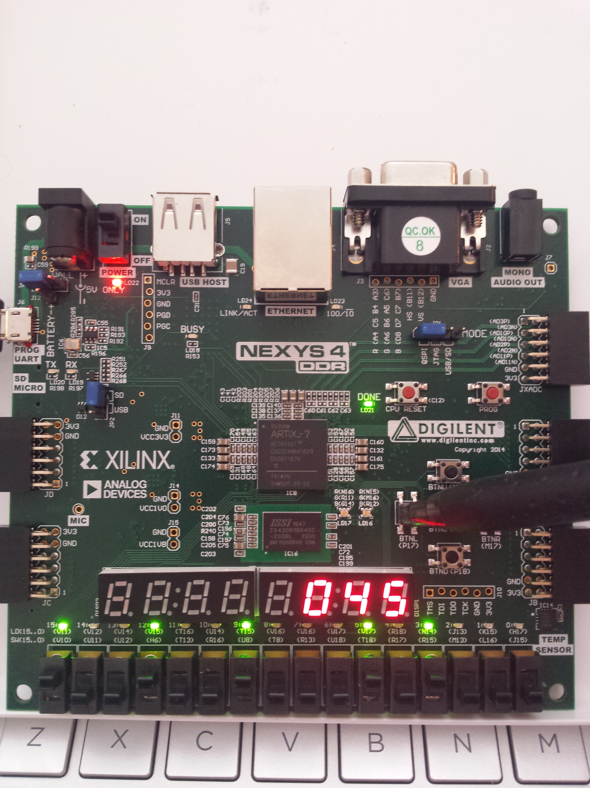

Figure 15:Output 45 after 5th Debouncer_button input from (3rd Debouncer_button input)

If the input switches were not changed, then the product would be constantly at 45, regardless of how many times the Debouncer_button was activated.

**Conclusion**

The combinational and pipelined multiplier modules were successfully created with no errors. The self-checking testbenches for both designs and the FPGA validation for the pipelined multiplier was also completed without errors. During the lab demo, we had to prepare different inputs to the FPGA board and test it similar to the hardware validation figures above which was also completed with no errors.

In conclusion this lab was a success, and we learned how to combine the usage of combinational and sequential storage building blocks to create a pipeline,

**Appendix**

1. **File *multiplier.v* - design source for the combinational multiplier**

`timescale 1ns / 1ps

module multiplier(input [3:0]A, input [3:0]B,

output [7:0] Product

);

reg [7:0] PP0, PP1, PP2, PP3;

reg [7:0] PP0_1, PP2_3;

wire co0_1, co2_3;

wire [3:0] sum0_1, sum2_3;

reg P_1st,P_2nd;

wire ci_P,co_P;

wire [3:0] temp0,temp1,temp2,temp3;

always@(A,B)

begin

assign PP0= {4'b0000, temp0};

assign PP1= {3'b000, temp1 , 1'b0};

assign PP2= {2'b00, temp2 , 2'b00};

assign PP3= {1'b0, temp3 , 3'b000};

assign PP0_1 = {2'b00, co0_1, sum0_1, PP0[0]};

assign PP2_3 = {co2_3, sum2_3, PP2[2],2'b00};

end //endalways

//add PP0+PP1 ----still need to concatenate

CLA_adder PP01(.CarryIn0(0), .A(PP0[4:1]),.B(PP1[4:1]),.carry_out(co0_1), .Sum(sum0_1));

//add PP2+PP3 --still need to concatenate

CLA_adder PP23(.CarryIn0(0), .A(PP2[6:3]),.B(PP3[6:3]),.carry_out(co2_3), .Sum(sum2_3));

//add all PPs together

CLA_adder P_03(.CarryIn0(0), .A(PP0_1[3:0]),.B(PP2_3[3:0]),.carry_out(ci_P), .Sum(Product[3:0]));

CLA_adder P_47(.CarryIn0(ci_P), .A(PP0_1[7:4]),.B(PP2_3[7:4]),.carry_out(co_P), .Sum(Product[7:4]));

//like [3:0]A*B[i]

and_AB AB0(A,B[0], temp0);

and_AB AB1(A,B[1], temp1);

and_AB AB2(A,B[2], temp2);

and_AB AB3(A,B[3], temp3);

endmodule

1. **File *multiplier_tb.v* -self-checking testbench for combinational multiplier**

`timescale 1ns / 1ps

module multiplier_tb();

reg [3:0] A_tb;

reg [3:0] B_tb;

wire [7:0] product_tb;

reg [7:0] product_tb_ref;

integer a_i, b_i; //incrementers

integer ErrorCount;

multiplier DUT(.A(A_tb),.B(B_tb), .Product(product_tb));

initial begin

ErrorCount=0;

for(a_i=0; a_i<16; a_i=a_i+1) //4bits ----> 2^4=16

begin

assign A_tb=a_i;

for(b_i=0; b_i<16; b_i=b_i+1) //4bits --->2^4=16

begin

assign B_tb=b_i; #2;

assign product_tb_ref=A_tb*B_tb;

if(product_tb_ref!==product_tb )

begin

$display("Error at A=%b B=%b Par_product=%b and Inf_product=%b at time=%d", A_tb,B_tb,product_tb,product_tb_ref,$time);

ErrorCount=ErrorCount+1;

end//end if

end//end b_i

end//end a_i

$display("TEST SUCCESS! There were %d errors in the multiplier",ErrorCount);

end//end initial

endmodule

1. **File *PL_multiplier_main.v* - design source for the pipelined multiplier**

`timescale 1ns / 1ps

module PL_multiplier_main(input clock, input rst, input enable, input [3:0]A, input[3:0]B, output [7:0]P);

wire [7:0] AB_in;

wire [7:0] PP23_d, PP01_d;

wire [7:0] PP23_q, PP01_q;

wire [7:0] Product_d;

wire [7:0] Product_q;

D_Reg Input_Reg( .clk( clock ), .reset( rst ), .en( enable ), .d ( {A,B} ), .q( AB_in ));

PL_multiplier_sub1 And_Shift(.A(AB_in[7:4]), .B(AB_in[3:0]),.PP2plus3(PP23_d),.PP0plus1(PP01_d));

D_Reg Stage_Reg1( .clk( clock ), .reset( rst ), .en( enable ), .d ( PP01_d ), .q( PP01_q ));

D_Reg Stage_Reg2( .clk( clock ), .reset( rst ), .en( enable ), .d ( PP23_d ), .q( PP23_q ));

PL_multiplier_sub2 Add_all(.PP2plus3( PP23_q ), .PP0plus1( PP01_q ), .P( Product_d ));

D_Reg Output_Reg(.clk( clock ), .reset( rst ), .en( enable ), .d ( Product_d ), .q( P ));

Endmodule

1. **File *PL_multiplier_tb.v* - self-checking testbench for the pipelined multiplier**

`timescale 1ns / 1ps

module multiplier_PL_tb();

reg clock_tb;

reg [3:0] A_tb, B_tb;

wire [7:0] P_tb;

wire [7:0] P_ref;

wire[7:0] sig1,sig2;

reg [7:0] P_inferred;

integer ErrorCount;

integer a_i,b_i;

PL_multiplier_main Pipeline_Multiplication(.clock(clock_tb), .rst( 1'b0 ), .enable( 1 ), .A( A_tb ), .B( B_tb ), .P( P_tb ));

initial

begin

clock_tb=0;

ErrorCount=0;

for(a_i=0; a_i<16; a_i=a_i+1)//2^4=16

begin

assign A_tb=a_i; //#4;

for(b_i=0; b_i<16; b_i=b_i+1)//2^4=16

begin

assign B_tb=b_i;

P_inferred=A_tb*B_tb; #4;

if(P_tb!=P_ref)

begin

ErrorCount=ErrorCount+1;

$display("There was an error at A=%d B=%d and time=%d", A_tb, B_tb, $time);

end

end//end b_i

end//end a_i

$display("Test Successful! There were %d errors in the pipelined multiplier simulation.", ErrorCount);

$stop;

end//end initial

always #2 clock_tb<=~clock_tb;

//Delay inferred product so it matches with Pipelined Product

D_Reg In( .clk( clock_tb ), .reset( 0 ), .en( 1 ), .d ( P_inferred ), .q( sig1 ));

D_Reg Stage( .clk( clock_tb ), .reset( 0 ), .en( 1 ), .d ( sig1 ), .q( sig2 ));

D_Reg Out( .clk( clock_tb ), .reset( 0 ), .en( 1 ), .d ( sig2 ), .q( P_ref ));

endmodule

1. **File *D_Reg.v* - design source for parameterized D-register**

`timescale 1ns / 1ps

module D_Reg #(parameter WIDTH = 8) (input clk, reset,input en, input[WIDTH-1:0] d,

output reg [WIDTH-1:0] q);

// asynchronous, active HIGH reset w. enable input

always@(posedge clk, posedge reset)

if (reset) q <= 0;

else if (en) q <= d;

else q <= q;

Endmodule

1. **File *PL_multiplier_sub1.v* - submodule to AND A and B, zero pad, and sum PP0 with PP1 and PP2 with PP3**

`timescale 1ns / 1ps

module PL_multiplier_sub1(input [3:0]A, input [3:0]B,

output [7:0]PP2plus3, output [7:0]PP0plus1);

wire [7:0] PP0, PP1, PP2, PP3;

wire [3:0] temp0,temp1,temp2,temp3;

wire [3:0] sum0_1, sum2_3; //can't be reg- concurrent assignment

wire co0_1,co2_3;

assign PP0= {4'b0000, temp0};

assign PP1= {3'b000, temp1 , 1'b0};

assign PP2= {2'b00, temp2 , 2'b00};

assign PP3= {1'b0, temp3 , 3'b000};

assign PP0plus1 = {2'b00, co0_1, sum0_1, PP0[0]};

assign PP2plus3 = {co2_3, sum2_3, PP2[2],2'b00};

//like [3:0]A*B[i]

and_AB AB0(A,B[0], temp0);

and_AB AB1(A,B[1], temp1);

and_AB AB2(A,B[2], temp2);

and_AB AB3(A,B[3], temp3);

//add PP0+PP1 ----still need to concatenate

CLA_adder PP01(.CarryIn0(1'b0), .A(PP0[4:1]),.B(PP1[4:1]),.carry_out(co0_1), .Sum(sum0_1));

//add PP2+PP3 --still need to concatenate

CLA_adder PP23(.CarryIn0(1'b0), .A(PP2[6:3]),.B(PP3[6:3]),.carry_out(co2_3), .Sum(sum2_3));

endmodule

1. **File *and_AB.v* - helper module to AND all A bits to one B bit ---A[3:0]*B[i]**

`timescale 1ns / 1ps

module and_AB( input [3:0] A, input B, output reg [3:0] and_Ab);

integer i;

always@(A,B)

begin

for(i=0; i<4; i=i+1)

begin

and_Ab[i]=A[i]&B;

end

end//end initial

endmodule

1. **File *CLA_adder.v* - design code for the Carry Look-Ahead adder**

`timescale 1ns / 1ps

module CLA_adder(input CarryIn0, input [3:0]A, input [3:0]B, output carry_out, output [3:0] Sum);

reg c_o,c_i; //carry out and in

reg i;//increment

wire [4:0] carry_in;

wire [3:0] g_cin;

wire [3:0] p_sum;

assign carry_in[0]=CarryIn0;

half_adder HA_1 (.a(A[0]), .b(B[0]), .g(g_cin[0]), .p(p_sum[0]) );

//p_i=a_i XOR b_i //g_i=a_i AND b_i

assign carry_in[1]=g_cin[0]+(carry_in[0]&p_sum[0]); //c_i+1=g_i + p_ic_i

assign Sum[0]=(carry_in[0]^ p_sum[0]); //s_i= p_i XOR c_i

half_adder HA_2 (.a(A[1]), .b(B[1]), .g(g_cin[1]), .p(p_sum[1]) );

assign carry_in[2]=g_cin[1]+(carry_in[1]&p_sum[1]);

assign Sum[1]=(carry_in[1]^ p_sum[1]);

half_adder HA_3 (.a(A[2]), .b(B[2]), .g(g_cin[2]), .p(p_sum[2]) );

assign carry_in[3]=g_cin[2]+(carry_in[2]&p_sum[2]);

assign Sum[2]=(carry_in[2]^ p_sum[2]);

half_adder HA_4 (.a(A[3]), .b(B[3]), .g(g_cin[3]), .p(p_sum[3]) );

assign carry_in[4]=g_cin[3]+(carry_in[3]&p_sum[3]);

assign Sum[3]=(carry_in[3]^ p_sum[3]);

assign carry_out=carry_in[4];

endmodule

1. **File *half_adder.v -* half adder module used in the four bit CLA adder**

`timescale 1ns / 1ps

module half_adder(a, b, g, p);

input a, b;

output reg g,p;//c_out, sum;

always@(a,b)

begin

p = a ^ b; //p_i // This part can be coded as

g = a & b; //g_i // assign {c_out, sum} = a + b;

end

endmodule

1. **File *PL_multiplier_sub2.v* - submodule to add all PP’s together**

`timescale 1ns / 1ps

module PL_multiplier_sub2(input [7:0]PP2plus3, input [7:0]PP0plus1,

output [7:0]P);

wire ci_P, co_P;

//add all PPs together

CLA_adder P_03(.CarryIn0(1'b0), .A(PP0plus1[3:0]),.B(PP2plus3[3:0]),.carry_out(ci_P), .Sum(P[3:0]));

CLA_adder P_47(.CarryIn0(ci_P), .A(PP0plus1[7:4]),.B(PP2plus3[7:4]),.carry_out(co_P), .Sum(P[7:4]));

endmodule

1. **File *button_debouncer.v* - design source for debouncer**

module button_debouncer #(parameter depth = 16) (

input wire clk, /* 5 KHz clock */

input wire button, /* Input button from constraints */

output reg debounced_button

);

localparam history_max = (2**depth)-1;

/* History of sampled input button */

reg [depth-1:0] history;

always @ (posedge clk)

begin

/* Move history back one sample and insert new sample */

history <= { button, history[depth-1:1] };

/* Assert debounced button if it has been in a consistent state throughout history */

debounced_button <= (history == history_max) ? 1'b1 : 1'b0;

end

endmodule

1. **File *clk_gen.v* - utility module to generate the clock**

module clk_gen (input clk100MHz, rst,

output reg clk_4sec, clk_5KHz);

integer count1, count2;

always @ (posedge clk100MHz)

begin

if (rst)

begin

count1 = 0; clk_4sec = 0;

count2 = 0; clk_5KHz = 0;

end

else

begin

if (count1 == 200000000)

begin

clk_4sec = ~clk_4sec;

count1 = 0;

end

if (count2 == 10000)

begin

clk_5KHz = ~clk_5KHz;

count2 = 0;

end//endif

count1 = count1 + 1;

count2 = count2 + 1;

end

end//end always

endmodule

1. **File *bcd_to_7seg.v* - utility module to display LEDs on 7-seg**

module bcd_to_7seg (input c_o, input [3:0] BCD,

output reg [7:0] carryout, output reg [7:0] s_10s, output reg [7:0] s_1s);

reg [7:0] s;

reg[4:0] wCarryOut;

integer digit_10s;

integer digit_1s;

always @ (c_o,BCD)

begin

wCarryOut={c_o,BCD}; //if want to include carry out in sum(5 bits)

// wCarryOut={1'b0,BCD}; //if don't want carryout in sum(4 bits)

digit_10s = wCarryOut/10;

digit_1s = wCarryOut%10;

case(c_o)

0: carryout = 8'b10001000; //active low outputs

1: carryout = 8'b11101101;

endcase

case (digit_1s)//ones place

0: s_1s = 8'b10001000; //active low outputs

1: s_1s = 8'b11101101; //s6 s5 s4 ... s0

2: s_1s = 8'b10100010;

3: s_1s = 8'b10100100; //display 3 on 7-seg

4: s_1s = 8'b11000101; //display 4 on 7-seg

5: s_1s = 8'b10010100; //display 5 on 7-seg

6: s_1s = 8'b10010000; //and so on...

7: s_1s = 8'b10101101;

8: s_1s = 8'b10000000;

9: s_1s = 8'b10000100;

default: s_1s = 8'b01111111;

endcase

case (digit_10s)//ones place

0: s_10s= 8'b10001000; //active low outputs

1: s_10s = 8'b11101101; //s6 s5 s4 ... s0

2: s_10s = 8'b10100010;

3: s_10s = 8'b10100100; //display 3 on 7-seg

4: s_10s = 8'b11000101; //display 4 on 7-seg

5: s_10s = 8'b10010100; //display 5 on 7-seg

6: s_10s = 8'b10010000; //and so on...

7: s_10s = 8'b10101101;

8: s_10s = 8'b10000000;

9: s_10s = 8'b10000100;

default: s_10s = 8'b01111111;

endcase

end

endmodule

1. **File *led_mux.v* - utility module to select what goes to which 7-seg**

`timescale 1ns / 1ps

//for multiplexing signals to be displayed on 7seg

module led_mux(input clk, rst,

input [7:0] LED7, LED6, LED5, LED4, LED3, LED2, LED1, LED0,

output [7:0] LEDSEL, LEDOUT); //which 7 seg and what digit to display

reg [2:0] index;

reg [15:0] led_ctrl;

assign {LEDSEL, LEDOUT} = led_ctrl;

always @ (posedge clk) index <= (rst) ? 3'b0 : (index + 3'd1);

always @ (index, LED0, LED1, LED2, LED3, LED4, LED5, LED6, LED7)

begin

case (index)

0: led_ctrl <= {8'b11111110, LED0};

1: led_ctrl <= {8'b11111101, LED1};

2: led_ctrl <= {8'b11111011, LED2};

3: led_ctrl <= {8'b11110111, LED3};

4: led_ctrl <= {8'b11101111, LED4};

5: led_ctrl <= {8'b11011111, LED5};

6: led_ctrl <= {8'b10111111, LED6};

7: led_ctrl <= {8'b01111111, LED7};

default: led_ctrl <= {8'b11111111, 8'hFF};

endcase

end

endmodule

1. **File *PL_multiplier_fpga.v* - top level module for pipeline multiplier fpga verification**

`timescale 1ns / 1ps

module multiplier_PL_fpga(input clk100MHz, rst, enable, Debouncer_button,

input [3:0]A, input[3:0]B,

output [3:0] A_LED, [3:0] B_LED, //display input LEDs

output enable_LED,

output [7:0] LEDSEL, [7:0] LEDOUT); //display Product on 7seg

assign A_LED=A;

assign B_LED=B;

supply1 [7:0] vcc;

wire DONT_USE, clk_5KHz;

wire Debouncer_out;

wire[7:0]Product;

wire [7:0] hundreds, tens, ones;

multiplier_PL_main Pipeline_Multiplication(.clock( Debouncer_out ), .rst( rst ), .enable( enable ), .A( A ), .B( B ), .P( Product ) );

clk_gen autoClock(.clk100MHz( clk100MHz ), .rst( rst ), .clk_4sec( DONT_USE ), .clk_5KHz( clk_5KHz ));

button_debouncer #8 Debouncer(.clk( clk_5KHz),

.button( Debouncer_button ), /* Input button from constraints */

.debounced_button( Debouncer_out ) );

bcd_to_7seg BCD (Product, hundreds, tens, ones);

led_mux LED_ones (clk_5KHz, rst,

vcc, vcc, vcc, vcc, vcc, hundreds, tens, ones, //activelow so vcc

LEDSEL, LEDOUT);

assign enable_LED=enable;

assign A_LED=A;

assign B_LED=B;

endmodule

1. **File *PL_multiplier_fpga.xdc* - constraint file for the pipelined multiplier**

#Clock

set_property -dict {PACKAGE_PIN E3 IOSTANDARD LVCMOS33} [get_ports {clk100MHz}];

create_clock -add -name sys_clk_pin -period 10.00 -waveform {0 5} [get_ports {clk100MHz}];

set_property -dict {PACKAGE_PIN N17 IOSTANDARD LVCMOS33} [get_ports {rst}];

set_property -dict { PACKAGE_PIN V10 IOSTANDARD LVCMOS33 } [get_ports { enable }]; #sw[15]

##Input B

set_property -dict { PACKAGE_PIN R15 IOSTANDARD LVCMOS33 } [get_ports { B[0] }]; #IO_L13N_T2_MRCC_14 Sch=sw[3]

set_property -dict { PACKAGE_PIN R17 IOSTANDARD LVCMOS33 } [get_ports { B[1] }]; #IO_L12N_T1_MRCC_14 Sch=sw[4]

set_property -dict { PACKAGE_PIN T18 IOSTANDARD LVCMOS33 } [get_ports { B[2] }]; #IO_L7N_T1_D10_14 Sch=sw[5]

set_property -dict { PACKAGE_PIN U18 IOSTANDARD LVCMOS33 } [get_ports { B[3] }]; #IO_L17N_T2_A13_D29_14 Sch=sw[6]

#Input A

set_property -dict { PACKAGE_PIN U8 IOSTANDARD LVCMOS18 } [get_ports { A[0] }]; #sw[9]

set_property -dict { PACKAGE_PIN R16 IOSTANDARD LVCMOS33 } [get_ports { A[1] }]; #sw[10]

set_property -dict { PACKAGE_PIN T13 IOSTANDARD LVCMOS33 } [get_ports { A[2] }]; #sw[11]

set_property -dict { PACKAGE_PIN H6 IOSTANDARD LVCMOS33 } [get_ports { A[3] }]; #sw[12]

##Input Debouncer Button

set_property -dict { PACKAGE_PIN P17 IOSTANDARD LVCMOS33 } [get_ports { Debouncer_button }];

#Display Input enable

set_property -dict { PACKAGE_PIN V11 IOSTANDARD LVCMOS33 } [get_ports { enable_LED }]; #led[15]

#Display Input B

set_property -dict { PACKAGE_PIN N14 IOSTANDARD LVCMOS33 } [get_ports {B_LED[0] }]; #led[3]

set_property -dict { PACKAGE_PIN R18 IOSTANDARD LVCMOS33 } [get_ports {B_LED[1] }]; #led[4]

set_property -dict { PACKAGE_PIN V17 IOSTANDARD LVCMOS33 } [get_ports {B_LED[2] }]; #Iled[5]

set_property -dict { PACKAGE_PIN U17 IOSTANDARD LVCMOS33 } [get_ports {B_LED[3] }]; #led[6]

#Display Input A

set_property -dict { PACKAGE_PIN T15 IOSTANDARD LVCMOS33 } [get_ports { A_LED[0] }]; #led[9]

set_property -dict { PACKAGE_PIN U14 IOSTANDARD LVCMOS33 } [get_ports { A_LED[1] }]; #led[10]

set_property -dict { PACKAGE_PIN T16 IOSTANDARD LVCMOS33 } [get_ports { A_LED[2] }]; #led[11]

set_property -dict { PACKAGE_PIN V15 IOSTANDARD LVCMOS33 } [get_ports { A_LED[3] }]; # led[12]

#Which 7-segment display to use

set_property -dict {PACKAGE_PIN J17 IOSTANDARD LVCMOS33} [get_ports {LEDSEL[0]}]; #Far right7-seg

set_property -dict {PACKAGE_PIN J18 IOSTANDARD LVCMOS33} [get_ports {LEDSEL[1]}];

set_property -dict {PACKAGE_PIN T9 IOSTANDARD LVCMOS33} [get_ports {LEDSEL[2]}];

set_property -dict {PACKAGE_PIN J14 IOSTANDARD LVCMOS33} [get_ports {LEDSEL[3]}];

set_property -dict {PACKAGE_PIN P14 IOSTANDARD LVCMOS33} [get_ports {LEDSEL[4]}];

set_property -dict {PACKAGE_PIN T14 IOSTANDARD LVCMOS33} [get_ports {LEDSEL[5]}];

set_property -dict {PACKAGE_PIN K2 IOSTANDARD LVCMOS33} [get_ports {LEDSEL[6]}];

set_property -dict {PACKAGE_PIN U13 IOSTANDARD LVCMOS33} [get_ports {LEDSEL[7]}]; #far left7-seg

#What to display at the 7-seg displays ALL ACTIVE LOW

set_property -dict {PACKAGE_PIN K13 IOSTANDARD LVCMOS33} [get_ports {LEDOUT[0]}];

set_property -dict {PACKAGE_PIN K16 IOSTANDARD LVCMOS33} [get_ports {LEDOUT[1]}];

set_property -dict {PACKAGE_PIN P15 IOSTANDARD LVCMOS33} [get_ports {LEDOUT[2]}];

set_property -dict {PACKAGE_PIN L18 IOSTANDARD LVCMOS33} [get_ports {LEDOUT[3]}];

set_property -dict {PACKAGE_PIN R10 IOSTANDARD LVCMOS33} [get_ports {LEDOUT[4]}];

set_property -dict {PACKAGE_PIN T11 IOSTANDARD LVCMOS33} [get_ports {LEDOUT[5]}];

set_property -dict {PACKAGE_PIN T10 IOSTANDARD LVCMOS33} [get_ports {LEDOUT[6]}];

set_property -dict {PACKAGE_PIN H15 IOSTANDARD LVCMOS33} [get_ports {LEDOUT[7]}];